[jxu72364@usc.edu](mailto:jxu72364@usc.edu)

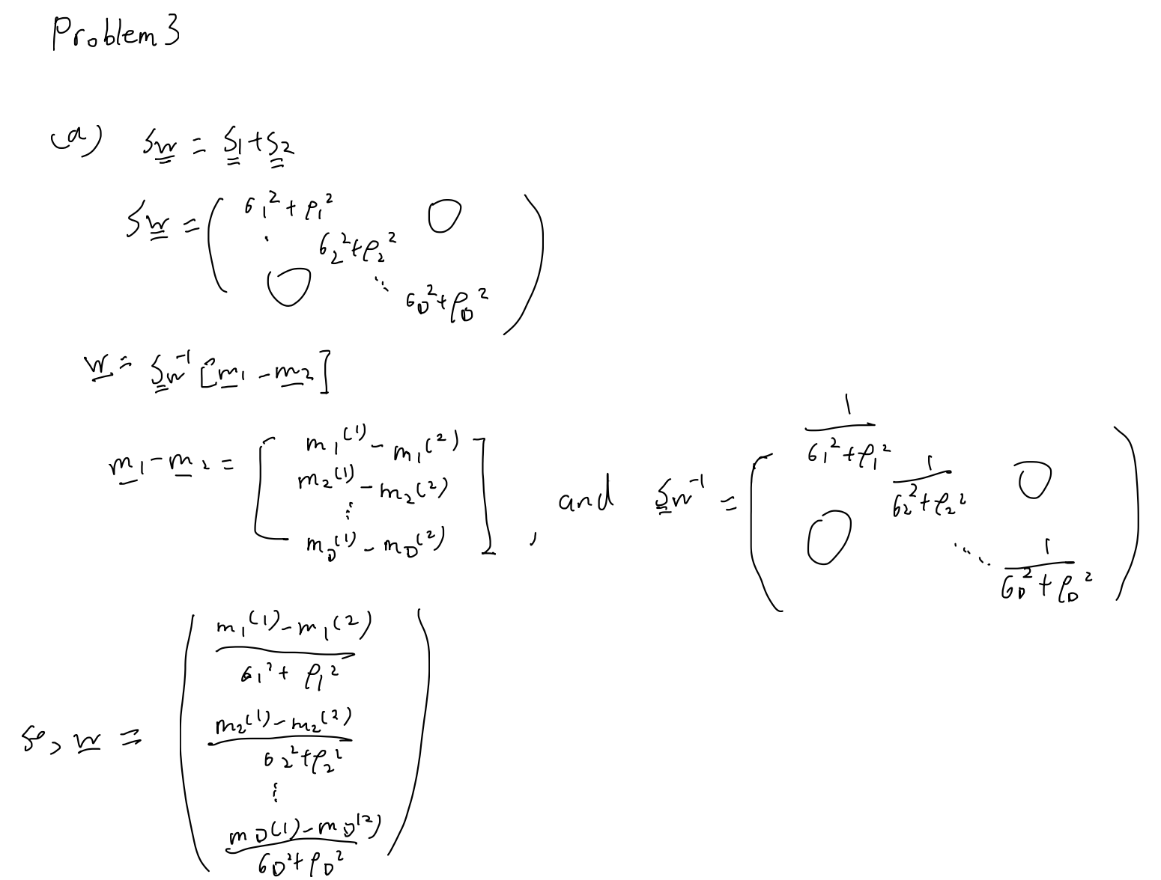

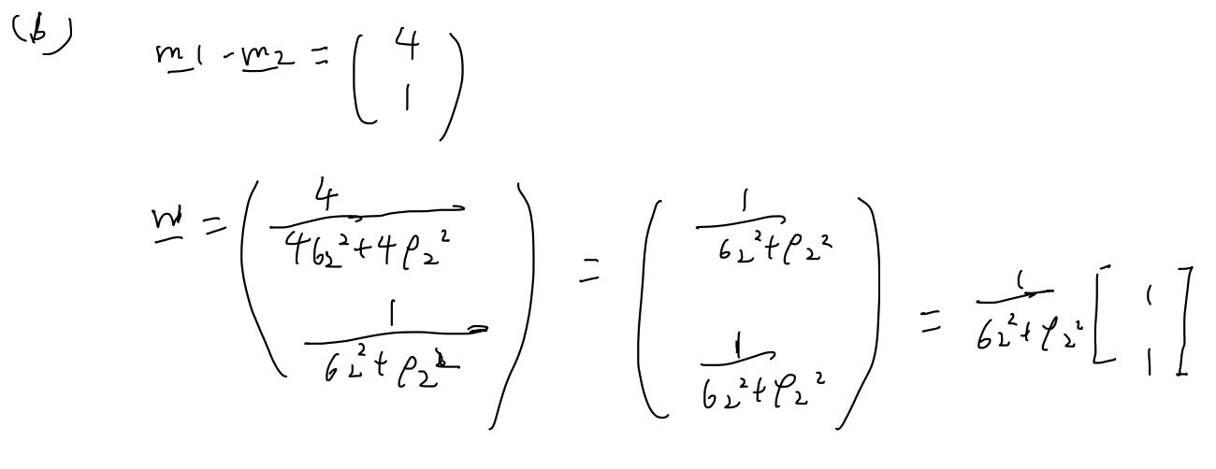

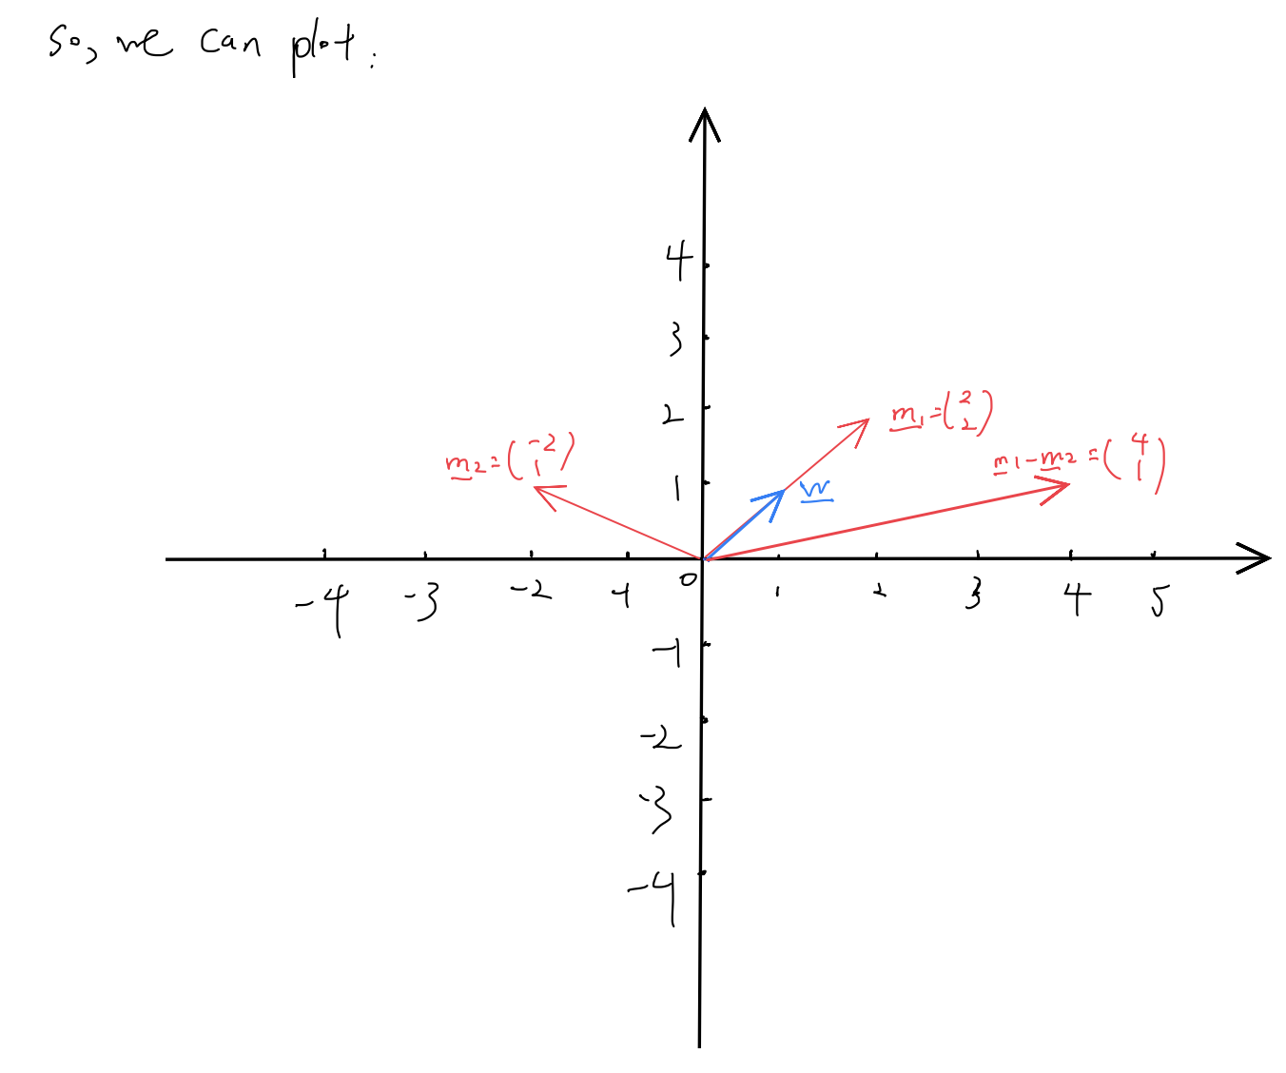

**(C)**

Although for this problem the direction for (m1 – m2) and W is same, I think W makes more sense for a 1D feature direction, because m1 – m2 only consider about the distance between projected class means, but we should consider another target, which is to make data points in each class as close as possible.

Therefore, W makes more sense for a 1D feature space direction.